hosted rest api on Cloud foundry:

<https://c1-cf.cfapps.io/browser/index.html#/>

to start mongodb:

cmd:> mongod –dbpath=”c:/data/db”;

cmd:> mongo

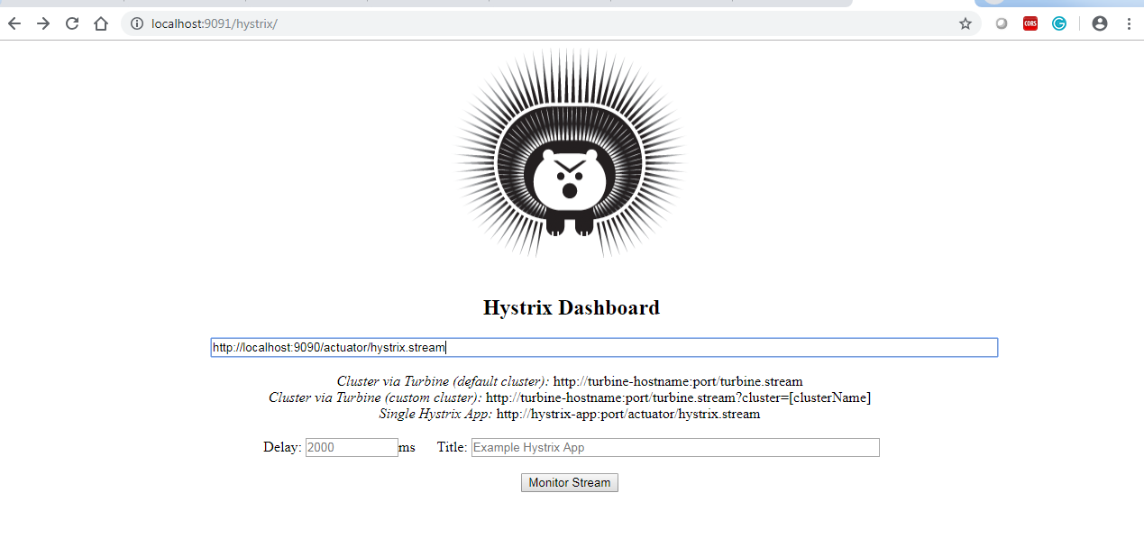

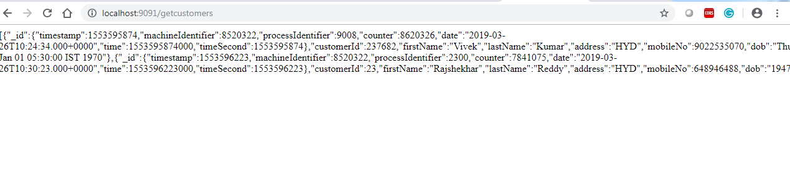

Then matrix will be updated

